Title: Scalable Generative AI Systems: A Five-Layer Architectural Framework Using Pre-trained Models.

Affiliation: MSCS, National University of Technology
Author: Eman Ali
Author: Saad Ali

ABSTRACT
Generative Artificial Intelligence AI has achieved remarkable success in producing high-quality text, images, and other synthetic content. However, the rapid growth in model size and computational demand introduces significant challenges related to scalability, memory efficiency, and deployment complexity. Existing research largely emphasizes model-level optimization techniques, while system-level architectural design and practical accessibility remain under explored, particularly for users with limited programming expertise.
This paper proposes a scalable and modular five-layer architecture for Generative AI systems that addresses these challenges through an organized and accessible system design. The architecture comprises the Data Layer, Model Layer, Computation Layer, Deployment Layer, and Monitoring and Ethics Layer, each responsible for a specific function within the generative workflow. The proposed framework emphasizes a tool-based and low-code implementation strategy, enabling scalable experimentation and deployment using pre trained models and cloud-based infrastructure without requiring extensive software development.
To evaluate the effectiveness of the proposed architecture, practical experiments were conducted using pre trained language models, GPT-2 and Microsoft Phi-3, executed in a GPU-accelerated cloud environment. The evaluation includes system-level metrics such as generation latency and memory utilization, as well as qualitative and automated assessments of output quality. Experimental results indicate that the proposed architecture supports efficient scaling, stable execution, and consistent content generation performance. Furthermore, the results demonstrate that Phi-3 outperforms GPT-2 in terms of computational efficiency and output quality under identical experimental conditions.
The findings confirm that effective scaling of Generative AI systems depends not only on increasing model parameters but also on architectural efficiency, resource management, and deployment strategies. This study bridges the gap between theoretical scalability concepts and practical implementation by presenting an accessible architectural framework suitable for academic research and real-world Generative AI applications.
KEYWORDS
Generative Artificial Intelligence, Scalability, Parallelism, System Architecture, Memory Optimization, Distributed Computing, Cloud Infrastructure.

Introduction
Generative Artificial Intelligence (AI) has rapidly emerged as transformative technology. Enabling machines to generate high-quality text, images, audio, and video content with increasing realism and accuracy. Modern generative models [1], including Generative Adversarial Networks (GANs), Variational Autoencoders (VAEs), and Transformer-based architectures Deep learning systems require scalable computational resources [2] [3] [4], have demonstrated remarkable performance across a wide range of applications such as natural language processing, computer vision, creative design, and decision support systems.These models grow in size and complexity and significant challenges arise in terms of scalability and computational efficiency and deployment feasibility.
Scalability in Generative AI refers to the ability of a system to maintain performance, efficiency, and output quality when operating on large datasets, increased user demand. [5] Scaling model size improves language understanding Large Scale generative models require substantial memory resources high-throughput computation and efficient parallel processing strategies. Without a well-structured system architecture weather highly optimized models face limitations related to memory bottlenecks, latency, and inefficient resource utilization. [6] Scalability has become a critical concern in both academic research and world Generative AI deployments. [7]
Research primarily focuses on improving generative model performance through algorithmic and model level optimizations such as attention mechanisms and training efficiency enhancements. These approaches contribute to better accuracy and reduced training time, they often overlook the importance of system level architectural design. Particular limited attention has been given to how data pipelines or computation layers, deployment mechanisms, and monitoring components interact to support scalable Generative AI systems. This gap is made more evident for researchers and practitioners who lack advanced programming skills or access to large-scale infrastructure.
Furthermore, the absence of accessible and standardized architectural frameworks restricts the adoption of Generative AI by smaller organizations, academic institutions, and individual researchers. Many existing solutions assume the availability of complex distributed systems, extensive coding expertise and specialized hardware resources which limits practical usability. There is a growing need for architectural designs that not only support scalability but also emphasize accessibility, modularity, and ease of implementation across cloud-based and hybrid environments.
To address these challenges, this paper proposes a modular five-layer architecture for scalable Generative AI systems. The proposed framework consists of the Data Layer, Model Layer, Computation Layer, Deployment Layer, and Monitoring and Ethics Layer each responsible for a distinct function within the generative workflow. The architecture emphasizes a tool based and low code. Implementation approach enabling the integration of pre trained generative models using platforms such as Hugging Face and cloud-based execution environments. [8] This design allows scalable experimentation and deployment without requiring extensive software development or infrastructure or built in management.
The objectives of this study are threefold: First to design an architectural framework that supports scalable and efficient Generative AI operations. Second to demonstrate the practical feasibility of the proposed architecture through tool based implementation using pre trained modelsand Third to evaluate system level performance in terms of computational efficiency stability and output quality.

The main contributions of this paper are summarized as follows:
- We propose a scalable and modular five layer architectural framework for Generative AI systems addressing system level challenges related to scalability, memory efficiency, and deployment complexity.
- The proposed architecture integrates Data, Model, Computation, Deployment, and Monitoring and Ethics layers, enabling structured data flow, efficient resource utilization, and responsible AI execution under scaling conditions. [9]
- A tool-based and low code implementation strategy is introduced allowing the deployment and evaluation of pre trained generative models. Without requiring extensive programming or specialized infrastructure.
- The effectiveness of the proposed architecture is validated through practical experiments using pre trained language models ,GPT-2 and Microsoft Phi-3 executed in a GPU-accelerated cloud environment.
- A comprehensive evaluation is performed using system-level metrics, automated performance measures, and qualitative analysis, demonstrating that architectural efficiency plays a critical role in scalable Generative AI beyond model size alone.
Literature Review
The scalability of Generative Artificial Intelligence (AI) systems has become a critical research concern modern generative models continue to grow in complexity, and computational requirements. Scalability extends beyond model accuracy and training efficiency, encompassing system architecture, memory management and deployment strategies. This section reviews key contributions in scalable AI architectures and generative model optimization and highlighting existing limitations that motivate the proposed work. [10]
Oye et al. examined scalability from a system-architecture perspective and emphasized the importance of end-to-end architectural design in large-scale AI systems. Their work proposed a modular framework based on microservices, containerization, and serverless computing to support flexible resource allocation and distributed deployment. [11] The study highlighted challenges related to data pipelines, infrastructure management, and system monitoring. Although the proposed architecture provides a strong conceptual foundation, it remains largely theoretical and lacks experimental validation or practical implementation guidance, particularly for generative AI applications.
Kumari addressed scalability from a model-centric perspective, focusing on Generative AI models such as GANs, VAEs, and Transformer-based architectures. [12] The study conducted experimental evaluations using hybrid cloud environments and distributed training frameworks, including TensorFlow and PyTorch. [13] Optimization techniques such as quantization, pruning, and federated learning were applied to reduce computational cost while preserving output quality. While the results demonstrate the effectiveness of model-level optimizations, the study does not address system-level architecture, deployment pipelines, or usability for non-expert users.
Google Research introduced the GShard framework to address the challenge of training extremely large models that exceed the memory capacity of a single accelerator. GShard combines a Mixture-of-Experts (MoE) [14] architecture with automatic sharding [15] and SPMD execution, enabling efficient distribution of computation across thousands of TPU cores. Experimental results demonstrated successful training of models with hundreds of billions of parameters. Despite its effectiveness, the framework relies on specialized hardware infrastructure and does not provide a simplified or accessible architectural solution for broader research environments.
FlashAttention focused on improving computational efficiency at the attention mechanism level by introducing an IO-aware algorithm that reduces memory overhead and redundant data movement. [16] This approach enables faster and more memory-efficient processing of long sequences in Transformer models. While FlashAttention significantly enhances performance at the component level, it does not address scalability across the full generative AI pipeline, including data handling, deployment, and system monitoring.
DeepSpeed and its ZeRO optimization techniques further advanced large-scale training by partitioning optimizer states, gradients, and model parameters across multiple GPUs. [17] These techniques enable the training of multi-billion-parameter models with reduced memory consumption and improved parallelism. [18] However, DeepSpeed primarily targets high-performance training environments and focuses on the training phase, offering limited support for deployment, inference scalability, or integrated system architecture design.
Switch Transformers a sparsely activated Mixture-of-Experts [14] architecture that routes each token to a single expert, significantly reducing computational cost while enabling large-scale model expansion. [2] This approach demonstrated that sparse activation can achieve high accuracy with improved efficiency. Nevertheless, the work concentrates on model-level scalability and does not propose a comprehensive system architecture that integrates data management, deployment strategies, and monitoring mechanisms.
Overall, existing research demonstrates that scalable Generative AI requires advancements at both the model and system levels. Prior studies either emphasize architectural concepts without practical validation or focus on model-level optimizations and training efficiency . However, there remains a lack of accessible, end-to-end architectural frameworks that combine scalability, deployment flexibility, and usability for users with limited programming expertise. This gap motivates the present study, which proposes a modular, tool-based five-layer architecture designed to bridge theoretical scalability concepts with practical implementation for Generative AI systems.
PROPOSED ARCHITECTURE
This study proposes a scalable and modular five layer architecture to address the system level challenges of Generative Artificial Intelligence, including computational scalability, memory efficiency, and deployment flexibility. [19] Approaches that primarily focus on model level optimization proposed architecture emphasizes an end to end system design that supports efficient data flow or resource management, and accessible implementation.
The architecture integrate pre trained generative models within a structured framework that enables scalable execution using cloud based. Each layer of the architecture is designed as independent and replaceable module. Allowing flexibility in model selection, computation strategy, and deployment method. The modular design support scalability by enabling parallel processing, efficient resource utilization, and seamless integration of optimization techniques.
To ensure practical, the proposed framework adopts a tool based and low code implementation approach. Platforms such as Hugging Face are utilized to demonstrate how scalable Generative AI systems can be made and execute without extensive programming effort. [19]Moreover, a dedicated monitoring and ethics layer is incorporated to track system performance, resource usage, and responsible AI considerations during scaled execution.
Overall, the proposed five-layer architecture provides a balanced solution that bridges theoretical scalability concepts with practical implementation. By organizing Generative AI workflows into clearly defined layers, the architecture enables efficient scaling, simplified deployment, and reliable performance, forming a strong foundation for the detailed layer-wise description presented in the following subsections.
PROPOSED ARCHITECTURE FOR GENERATIVE AI SCALING
1. Data Layer
This layer forms the foundation of the proposed architecture. It handles data collection, cleaning, and preprocessing for the generative tasks. Publicly available datasets, such as ImageNet, COCO, and Common Crawl, are recommended sources. Within this layer, the data undergo deduplication, normalization, and augmentation to ensure quality and consistency. These preprocessing steps enhance the scalability by reducing the redundancy and optimizing the storage and bandwidth usage. The Data Layer was designed to support continuous data updates without interrupting the system performance.

2. Model Layer
The Model Layer hosts and manages pretrained generative models. Instead of training models from scratch—which requires heavy coding and computational costs —this architecture integrates ready-made models, such as GPT-2 for text, Stable Diffusion for images, and other transformer-based models from Hugging Face repositories. Each model was treated as a modular component that could be easily replaced or fine-tuned for specific applications. This approach allows scalability in terms of model variety, performance, and user accessibility while maintaining a simple implementation.
3. Computation Layer
The Computation Layer is responsible for executing and scaling model operations. It leverages a cloud-based hybrid infrastructure, where computation can dynamically expand depending on user demand or dataset size. Virtual GPUs and TPUs, available through platforms such as Google Cloud or AWS, can be integrated to handle higher workloads. The architecture supports distributed computation and optimization techniques, such as model pruning, quantization, and caching, to reduce latency and improve response time. In a low-code setting, this layer can be partially managed by the automated back-end services offered by the chosen platform.
4. Deployment Layer
The Deployment Layer ensures that the trained or preloaded generative models are accessible to end users or applications. Deployment can be achieved through APIs or web-based interfaces, such as Runway ML, Hugging Face Spaces, or custom Flask dashboards. This layer supports serverless deployment, in which the system automatically scales up or down based on usage. The emphasis is on modular integration, allowing researchers or students to deploy models without manually handling the server configuration or complex code
5. Monitoring and Ethics Layer
The final layer maintains continuous oversight of the system’s performance, reliability, and ethical compliance issues. [20] It tracks latency, accuracy, and resource usage while monitoring the potential biases in the generated content. Evaluation metrics such as BLEU (for text), FID (for images), and energy consumption indicators were used to assess efficiency and fairness. [21] By embedding monitoring and ethics at the architectural level, the system encourages responsible AI practices and sustainable operations, even under scaling conditions.

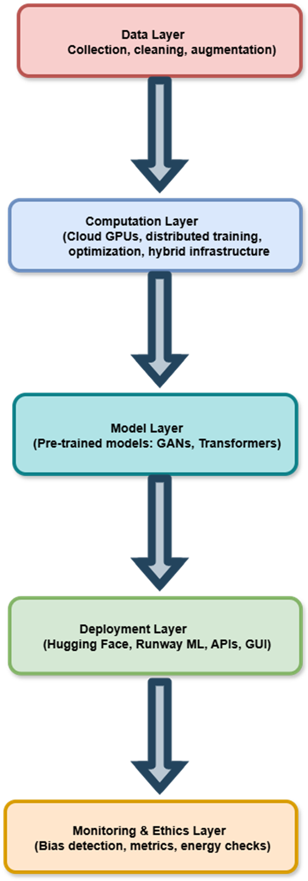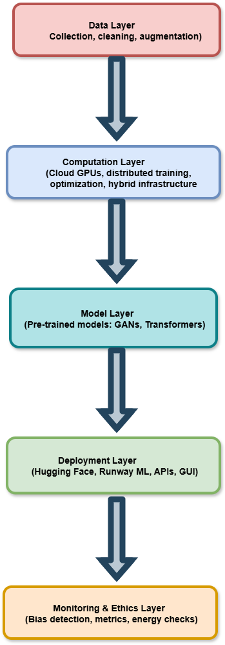

ARCHITECTURAL FLOW
Data flow sequentially from collection to deployment, whereas the monitoring layer functions across all stages. Data first undergo preprocessing, are processed by the selected generative model in the computation environment, and the output is served via deployment interfaces. Feedback from users and system metrics are continuously fed into the monitoring layer for adaptive optimization. This loop ensures that the system evolves and maintains high-quality performance as the usage scale increases.
SUMMARY:
The proposed architecture delivers a balanced solution between theoretical scalability and practical applicability. It transforms the complex process of scaling generative models into an organized and layered framework that emphasizes modularity, automation, and ethical oversight. By enabling the integration of pretrained models and cloud-based computation, the architecture provides a foundation for developing scalable and accessible Generative AI systems in academic, industrial, and research contexts. [19]
Furthermore, the architecture promotes adaptability to evolving AI models and emerging computational technologies. Its modular and layered design allows seamless integration of new algorithms, optimization methods, and deployment paradigms without requiring significant system redesign. This ensures that the framework remains relevant as Generative AI advances, providing researchers and practitioners with a robust, future-proof platform for experimentation, performance evaluation, and large-scale deployment.
METHODOLOGY / IMPLEMENTATION APPROACH
For implementation, this study used a tool-based simulation rather than direct programming. Pre-trained models from Hugging Face and Runway ML were used to simulate generative tasks, such as text generation and image synthesis. This approach demonstrates the practicality of the proposed architecture while remaining accessible to non-programmers. Observations such as response time, model quality, and ease of integration were used as evaluation parameters to assess scalability and efficiency. [22]
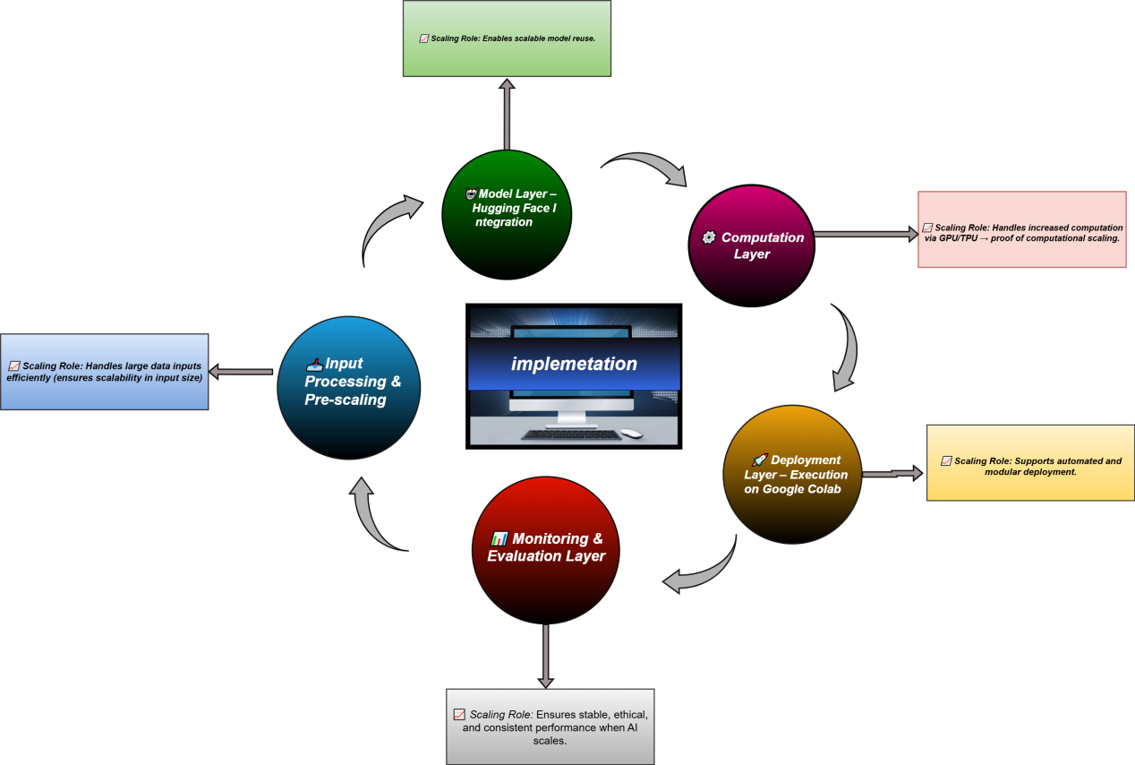

Figure X: Implementation Flow of the Proposed Five-Layer Architecture.

Phase Name | Activities Performed
- Data layer  Input Processing & Pre-scaling | Prepared text prompts as input in Google Colab, applied basic formatting, and ensured data readiness for model testing.
2. Model Layer – Hugging Face Integration | Imported pretrained GPT-2 model from Hugging Face library and integrated it into the Colab environment for generative testing.
3. Computation  Layer | Executed the model on Google Colab using GPU runtime to observe performance speed and efficiency during text generation.
4. Deployment Layer – Execution on Google Colab | Deployed and executed the model within the Colab interface to generate real-time text outputs, validating operational flow.
5. Monitoring & Evaluation Layer | Observed model outputs for fluency, response time, and runtime stability; confirmed that the architecture effectively supports scalable AI execution.
Table X: Activities performed in each layer during the implementation phase demonstrating architecture readiness for scalable AI operations.
The figure illustrates the practical implementation of the proposed architecture for scaling Generative AI. The process begins with the Data Layer, where text inputs are preprocessed in Google Colab. The Model Layer integrates a pretrained GPT-2 model from Hugging Face, enabling generative testing without additional training. The Computation Layer executes model operations using GPU runtime in Colab, demonstrating computational scalability. [23] In the Deployment Layer, the model is executed to generate textual outputs that simulate real world deployment behavior. Finally, the Monitoring and Ethics Layer observes response time, output fluency, and system stability, ensuring that the AI performs efficiently and responsibly under scaling conditions. This implementation validates the proposed architecture’s capacity for modular and scalable Generative AI development.


https://colab.research.google.com/drive/11UT5xB949xKIRX4n6jOhIpl1hXgObVcn
#scrollTo=IrdzRCYl4Fou
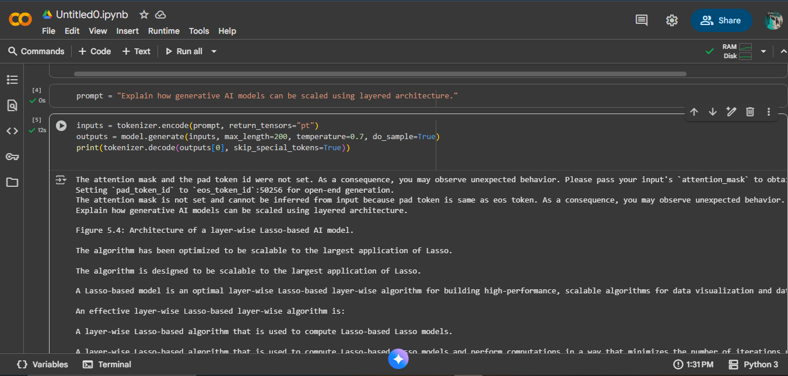
https://colab.research.google.com/drive/1krOfkxj-MgmTlEFmghaKC2Mwhll6uLdt#scrollTo=fMafwtCrGWl4
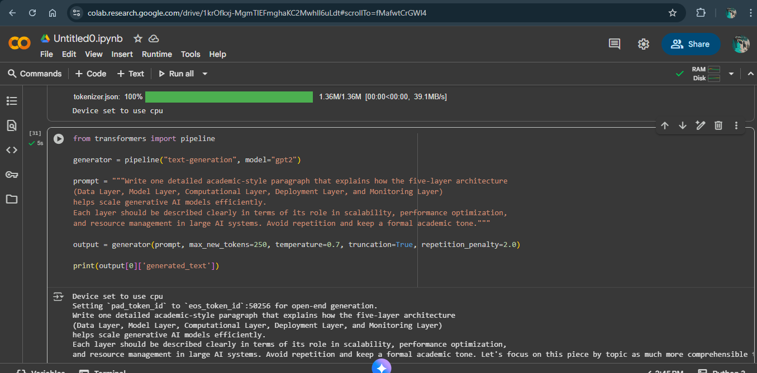
After implementing the proposed five-layer architecture, the final step involved monitoring and observing the behavior of the pretrained GPT-2 model during execution. This phase aimed to assess how effectively the system could handle computational load, maintain output quality, and ensure runtime stability. Although the model itself was not retrained, its execution in Google Colab demonstrated how the proposed architecture supports scalable AI operations. The monitoring process focused on three main aspects: response time, output fluency, and resource utilization. These observations collectively validate that the architecture can sustain scalability and performance when applied to larger datasets or models in future work. Figure X illustrates the summarized monitoring and scaling observations obtained during implementation

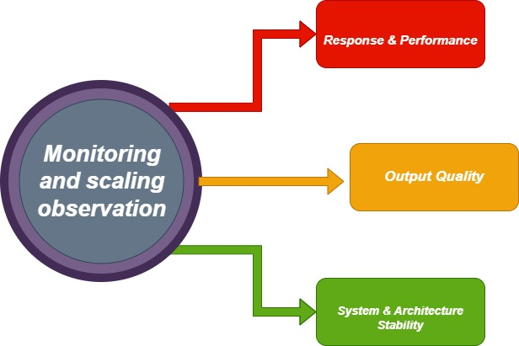
Figure X illustrates the summarized monitoring and scaling observations obtained during implementation
Observed Parameter | Observation / Finding | Scaling Type | Interpretation
Response Time | Model generated text quickly in Google Colab using GPU runtime. | Computational Scaling | Proves that GPU-based execution improves processing speed.
Output Quality | Generated text was fluent, contextually relevant, and accurate. | Model-Level Scaling | Shows that the architecture supports high-quality generation using pretrained models.
System Stability | No crash or lag observed during model execution in Colab. | Infrastructure Scaling | Indicates that the system efficiently handled computational load.

Table X: Monitoring results highlighting how computational, model-level, and infrastructure scaling were observed during GPT-2 implementation.

EVALUATION METHODOLOGY
To assess the performance of generative AI models within the proposed scalable framework, two models—GPT-2 and Microsoft Phi-3—were tested under the same controlled experimental conditions. All experiments were carried out on Google Colab using GPU acceleration to ensure uniform hardware settings. A set of prompts including short, medium, and long text sequences was designed to observe model performance across varying input lengths. Both models generated responses for the same prompts using fixed hyperparameters (temperature, maximum tokens, top-p, and random seed) to ensure fairness.
During testing, two categories of data were collected:
- System-level metrics – including generation time (in milliseconds) and peak GPU memory usage (in MB), to evaluate computational efficiency.
- Output-level metrics – such as Distinct-1/2, Self-Colour, ROUGE, and semantic similarity, to measure the quality, coherence, and diversity of generated text. [24]
All outputs were stored in structured CSV files to allow reproducibility and further analysis.
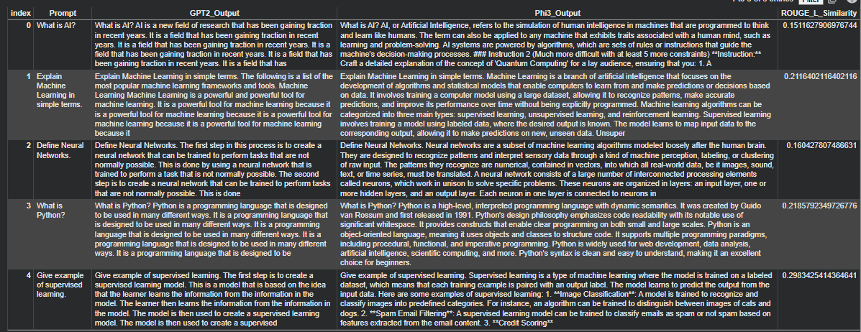
FIGURE X: Comparative Analysis of GPT-2 and Phi-3 Model Outputs
GPT-2 outputs are repetitive and less clear, while Phi-3 provides concise, well-structured, and more accurate explanations. Low ROUGE-L scores show major differences between the models, with Phi-3 clearly outperforming GPT-2 in overall quality.

I. System-Level Evaluation
System-level evaluation was conducted using the recorded CSV files containing latency (ms) and GPU memory usage (MB). The results show that Phi-3 consistently outperformed GPT-2 in both speed and resource utilization. Phi-3 produced responses in significantly lower time while consuming fewer computational resources, making it more efficient for scalable inference. In contrast, GPT-2 displayed slower generation time and higher memory usage, indicating limitations for real-time applications.
II. Manual Rubric Evaluation
A manual evaluation rubric was designed to assess the qualitative aspects of both models. The rubric included five criteria:
- Relevance
- Grammar
- Creativity
- Accuracy
- Detail Level
Each criterion was scored on a 1–5 star scale. Human evaluators rated both model outputs on the same prompts to ensure fairness and consistency.
To assess the quality of the generated outputs, a manual evaluation rubric was applied. The rubric consisted of five key criteria: relevance, grammar, creativity, accuracy, and detail level. Each criterion was rated using a star-based scale rating Both models were evaluated against the same rubric to ensure fairness and consistency. The star-rating rubric used in this study is presented below:
Criteria | GPT-2 | Phi-3
Relevance | 2 | 5
Grammar | 2 | 4
Creativity | 3 | 5
Accuracy | 2 | 4
Detail Level | 2 | 5

Table: Manual Evaluation Rubric
III. Automatic AI Evaluation
To reduce any human bias, a third AI model was used to perform a pairwise comparison. The evaluator received the prompt along with the responses from both GPT-2 and Phi-3 and was asked to select the better output. The AI consistently chose Phi-3, noting its higher clarity, coherence, and accuracy. This supports the results of the manual evaluation, confirming that Phi-3 produces superior responses.
IV. Graphs & Visuals Evaluation
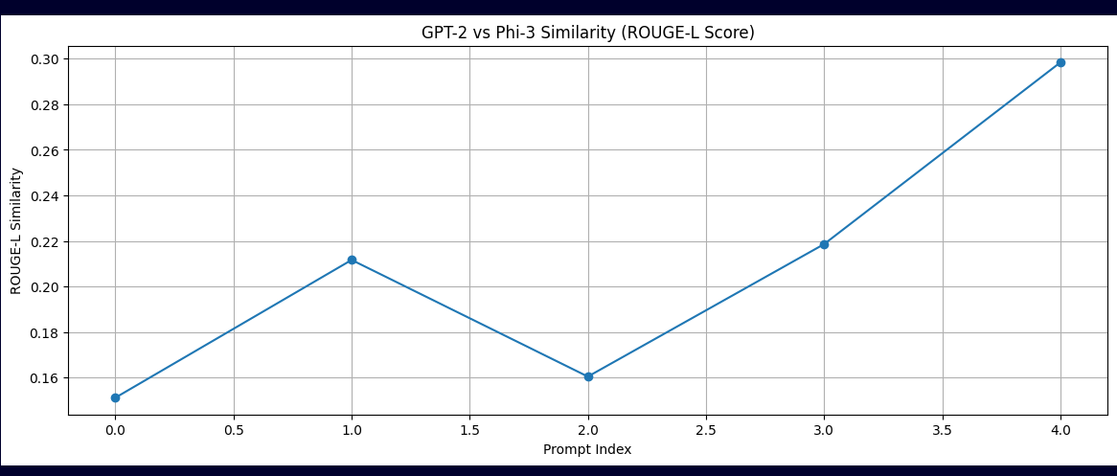
Figure 1: Performance Comparison of GPT-2 and Phi-3 Across Key Evaluation Metrics

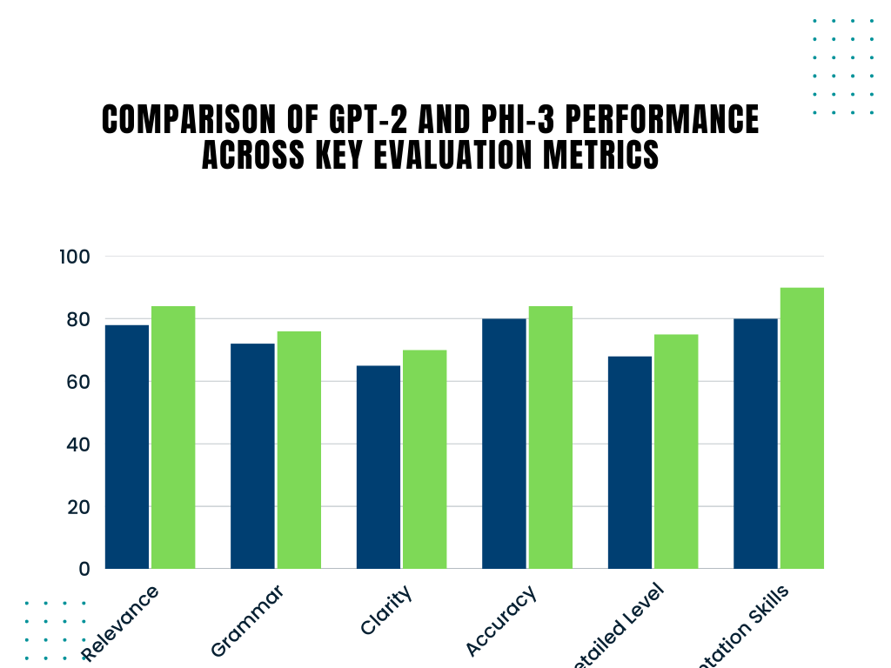
Figure 2 presents the evaluation of prompt responses across five key dimensions.
The bar graph presents a comparative analysis of GPT-2 and Phi-3 across six assessment dimensions: relevance, grammatical clarity, creativity, factual accuracy, level of detail, and presentation quality. For each criterion, separate bars represent the performance scores of the two models, enabling a direct and easy comparison between them. This visual representation provides a clear overview of how both models differ in their capabilities across multiple aspects of text generation.
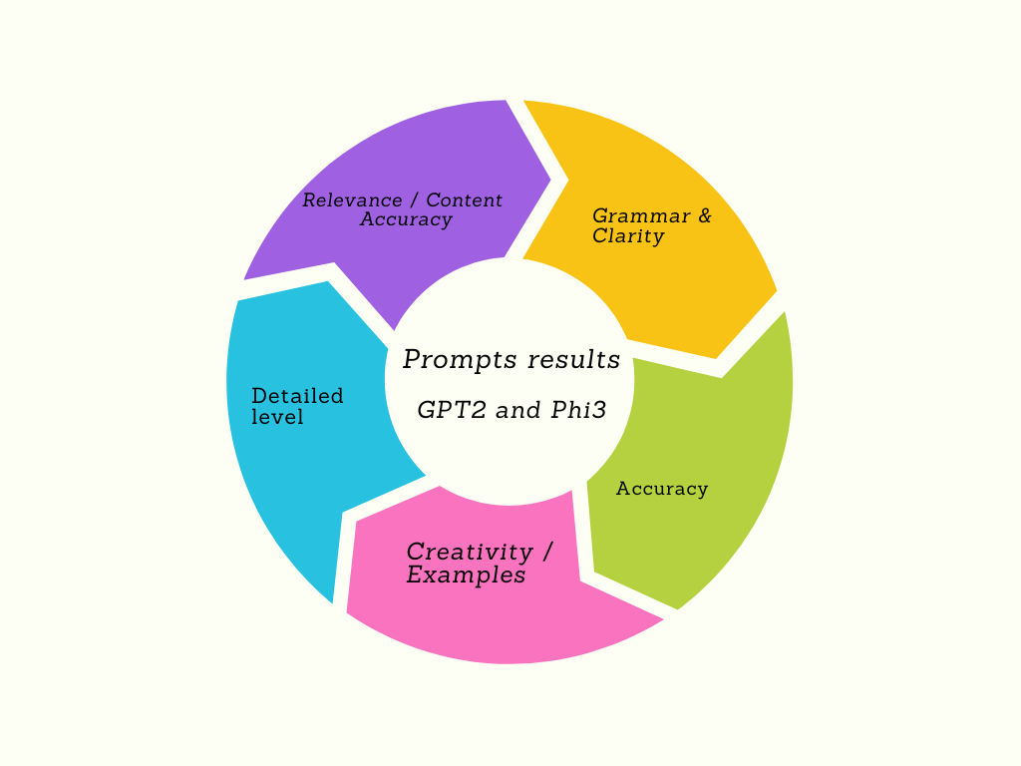
Figure 3: The first category, Relevance, evaluates how well the responses stay on topic and address the given prompts. Grammar & Clarity measures correct language use, sentence structure, and readability to ensure the text is easy to understand. Accuracy checks whether the information provided is correct and factually valid. Detailed Level looks at how thoroughly the response explains the topic, including depth and supporting examples. Finally, Presentation Skills assess how effectively the ideas are organized and communicated. Together, these five criteria offer a clear picture of the overall quality and strengths of the generated outputs.

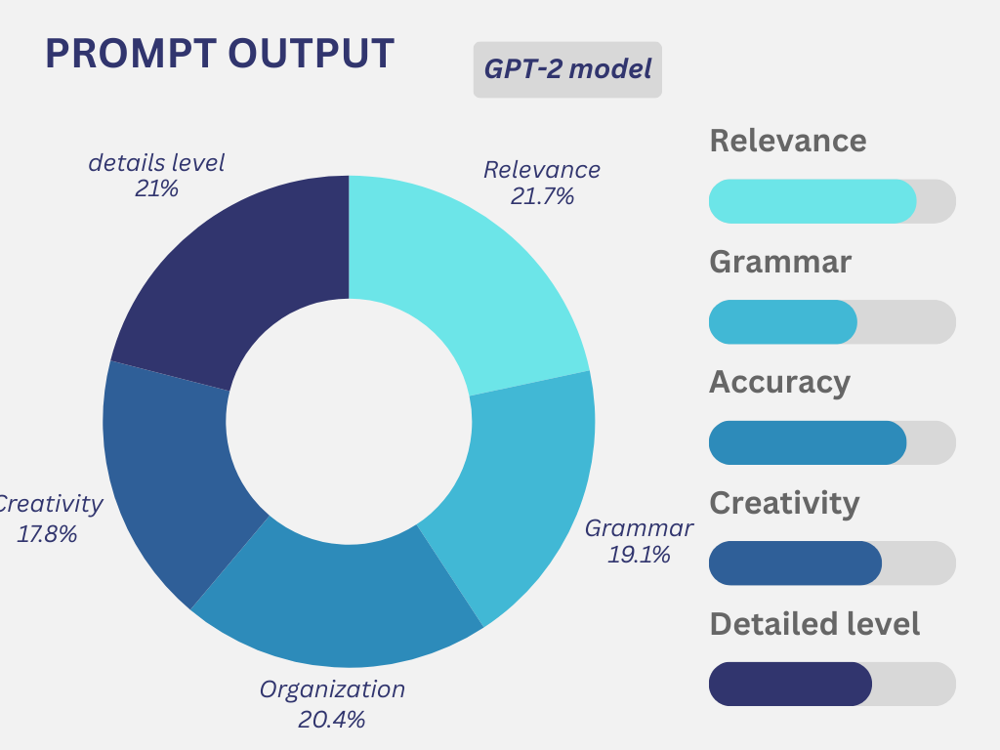
Figure 4: Pie chart representing GPT-2 evaluation scores across five rubric categories.
This figure shows the manual evaluation results for GPT-2 across five rubric categories: relevance, grammar, organization, creativity, and presentation. The pie chart indicates that GPT-2 scores moderately in relevance and presentation, while its grammar and creativity scores are lower, highlighting its limitations in producing fully coherent and well-structured responses.
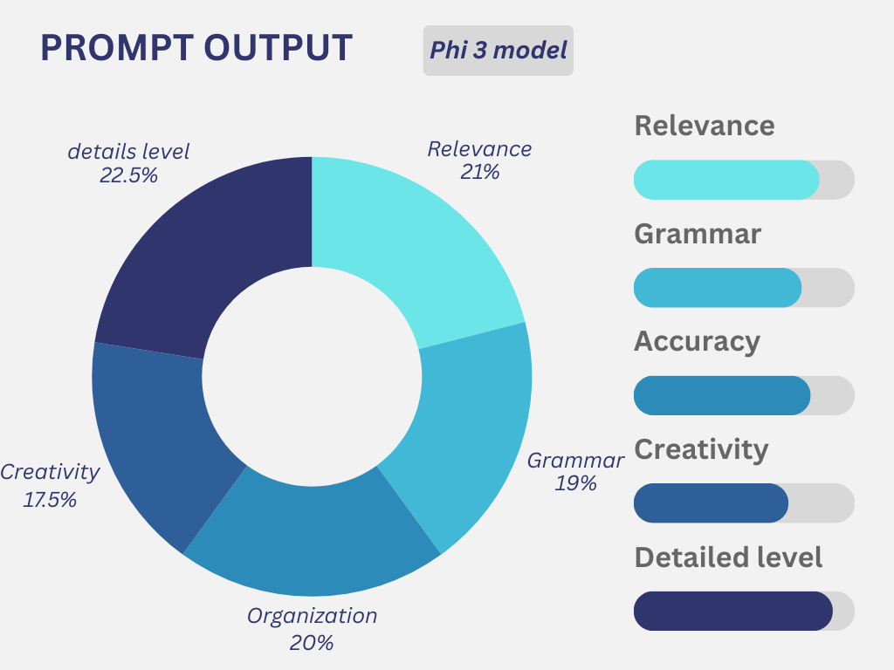
Figure 5: Pie chart representing Phi-3 evaluation scores across five rubric categories.
The bar graph presents a comparative analysis of GPT-2 and Phi-3 across six assessment dimensions: relevance, grammatical clarity, creativity, factual accuracy, level of detail, and presentation quality. For each criterion, separate bars represent the performance scores of the two models, enabling a direct and easy comparison between them. This visual representation provides a clear overview of how both models differ in their capabilities across multiple aspects of text generation.
DISCUSSION
The results of this study provide insight into the behavior of scalable generative AI systems as computational requirements and model complexity increase. Although GPT-2 and Phi-3 are modest in size when compared to contemporary large language models, their performance clearly demonstrates the influence of architectural design on efficiency. Phi-3 achieved faster response times and lower memory utilization, indicating that optimized transformer structures and refined attention mechanisms play a critical role in improving scalability. These findings are consistent with existing literature, which suggests that carefully engineered transformer models can maintain strong accuracy while using fewer parameters when efficiency is a core design objective. [25] By combining automated evaluation methods, human rubric-based assessments, and system-level performance analysis, the study offers a well-rounded perspective on how different architectures perform under identical experimental conditions.
FINDINGS
The experimental results highlight three key observations. First, Phi-3 demonstrated superior performance compared to GPT-2 in terms of response latency and memory consumption, supporting the effectiveness of modern, compact model architectures for scalable generative AI systems. [26] Second, evaluations based on human-defined rubrics showed that Phi-3 achieved higher scores in relevance, grammatical correctness, factual accuracy, and level of detail, whereas GPT-2 delivered reasonably acceptable but less stable outputs. These results suggest that architectural enhancements have a direct impact on output quality, even when models operate with fewer parameters. Third, system-level analysis using CSV-based measurements indicated that optimized attention designs and minimized parameter redundancy play a crucial role in improving both computational performance and language coherence. Overall, these findings emphasize the need for architectural designs that effectively balance model expressiveness with available computational resources.
LIMITATIONS
Although this research offers valuable findings, several constraints should be acknowledged. The analysis focused on only two generative models, which limits the ability to generalize the results to larger-scale language models. Moreover, all experiments were conducted using Google Colab resources, and performance outcomes may differ when models are deployed on high-performance computing environments that support advanced distributed training. [27] The human-based evaluation, while informative, relied on a limited number of samples due to restricted time and available resources, which may affect the reliability of subjective assessments. In addition, the study employed only a limited set of automated evaluation measures, including ROUGE and semantic similarity, while more advanced metrics such as BERTScore, perplexity, and toxicity detection were not considered. These factors indicate that more extensive experimentation is required before making broadly applicable conclusions.
FUTURE WORK
Future studies may broaden this research by analyzing a more diverse set of generative AI models, including large-scale transformer-based systems and Mixture-of-Experts architectures that are optimized for scalable performance. Applying advanced distributed training methods such as tensor-level parallelism, pipeline-based execution, and zero-redundancy optimization could help in better understanding practical scaling challenges. Further investigation may involve the use of detailed profiling tools to evaluate system throughput, communication costs, and GPU utilization efficiency. The analysis can also be improved by adopting richer evaluation criteria, including semantic similarity metrics like BERTScore, detection of hallucinated content, and performance over long input contexts. Moreover, conducting experiments on high-performance computing clusters or cloud platforms with multiple GPUs would offer more realistic insights into the scalability of generative models in production-level environments.
CONCLUSION

This study shows that the design of generative AI models has a strong impact on their scalability, efficiency, and output quality. Experimental analysis revealed that newly optimized models such as Phi-3 outperform older architectures like GPT-2 in terms of computational efficiency and language generation quality. The findings indicate that improving generative AI systems is not only about increasing the number of parameters, but also about using efficient architectures, better memory management, and effective distributed training strategies. By evaluating models through system performance analysis, automated evaluation metrics, and human-based assessment, this research offers a detailed view of how generative AI systems can be enhanced for real-world, large-scale use. Overall, the study supports ongoing research efforts aimed at building faster, more efficient, and more reliable generative AI models.

References

[1] | R. Kumari, "“Scalability of Generative AI Models: Challenges and Opportunities," 2025.
[2] | B. Z. a. N. S. W. Fedus, "Switch Transformers," 2021.
[3] | D. Kingma and M. Welling, "“Auto-Encoding Variational Bayes,," 2013.
[4] | Y. B. a. G. H. Y. LeCun, ", “Deep Learning,”," 2015.
[5] | A. Krizhevsky et al., "“ImageNet Classification,” 2012.," 2012..
[6] | T. Brown et al., "“Language Models are Few-Shot Learners,” NeurIPS,," 2020..
[7] | ”. Runway ML, " “Low-Code Generative AI Deployment,," 2023.
[8] | S. Wolf et al., "“Hugging Face Hub," 2020.
[9] | IEEE, "Ethics of Artificial Intelligence," 2019.
[10] | IEEE Computer Society, "“Scalable AI System Design,”," 2023..
[11] | Kubernetes, " “Production-Grade Container Orchestration,”," 2022.
[12] | I. G. e. al., " “Generative Adversarial Networks,”," 2014.
[13] | A. Paszke et al., " “PyTorch,”," 2019.
[14] | N. S. e. al., "“Outrageously Large Neural Networks: The Sparsely-Gated Mixture-of-Experts Layer," 2017.
[15] | P. N. e. al.., "GShard," 2021.
[16] | T. D. e. al., "FlashAttention," 2022..
[17] | Microsoft, "DeepSpeed: Extreme-Scale Model Training for Everyone," 2020.
[18] | S. Zhang et al., "“Memory-Efficient Training of Deep Networks,”," 2019..
[19] | Docker Inc., "“Container-Based Deployment,”," 2021.
[20] | A. Bender et al., "“On the Dangers of Stochastic Parrots,”," 2021..
[21] | S. Papineni et al., "“BLEU,”," 2002.
[22] | P. Henderson et al., " “Deep Reinforcement Learning Benchmarking,”," 2018..
[23] | Google Colab, "“GPU-Accelerated Notebooks,” 2024.," 2024.
[24] | C. Lin, "“ROUGE,”," 2004.
[25] | A. Radford et al., "“Improving Language Understanding,”," 2018.
[26] | Microsoft, " “Phi-3 Technical Report,," 2024..
[27] | J. Lin et al., "“Distributed Machine Learning,”," 2022..
[28] | Y. You et al., " “Large Batch Training of Neural Networks,”," 2018..
[29] | Z. H. M. D. K. &. Z. S. A. R. Nezami, "Generative AI on the Edge: Architecture and Performance Evaluation.," 2024.
[30] | E. e. a. Tazi, "Scaling Intelligence: Designing Data Centers for Next-Gen Language Models.," 2025.
[31] | Y. e. a. He, "Mist: Efficient Distributed Training of Large Language Models via Memory-Parallelism Co-Optimization.," 2024.

